**AI (ML DL) April15**

**Project**

**On**

Avalanche Forecasting

Using

Machine learning Algorithms

By Team 5

1) Jogi Prathusha

2) Chalamalasetti Baby Sri Lakshmi

3) Nandam Toneswari

4) Namburi Sasi Kumar

5) Vasi Stanes Dany

**Table of Contents**

|  |  |  |  |  |  |  |
| --- | --- | --- | --- | --- | --- | --- |
| **1** | |  | **INTRODUCTION** | |  | |
|  | |  | 1.1 Overview | |  | |
|  | |  | 1.2 Purpose | |  | |
| **2** | |  | **LITERATURE SURVEY** | |  | |
|  | |  | 2.1 Existing problem | | | |
|  | |  | 2.2 Proposed solution | | | |
| **3** | |  | **THEORITICAL ANALYSIS** | |  | |
|  | |  | 3.1 Block diagram | |  | |
|  | |  | 3.2 Hardware / Software designing | | | |
| **4** | |  | **EXPERIMENTAL INVESTIGATIONS** | | | |
| **5** | |  | **FLOWCHART** | |  | |
| **6** | |  | **RESULT** |  |  | |
| **7** | |  | **ADVANTAGES & DISADVANTAGES** | | | |
| **8** | |  | **APPLICATIONS** | |  | |
| **9** | |  | **CONCLUSION** | |  | |
| **10** | |  | **FUTURE SCOPE** | |  | |
| **11** | |  | **BIBILOGRAPHY** | |  | |
|  | |  | **APPENDIX** | |  | |
|  |  | | A. Source code | |  | |

1. **Introduction**

**1.1Overview:**

The word Avalanche refers to snow and ice. It means a mass of snow, ice, rocks, slush falling rapidly down a mountain. Snow avalanches are among the most destructive natural hazards threatening human life, ecosystems, built structures, and landscapes in mountainous regions. Each year avalanche kills more than 150 people worldwide. The most common cause of death by avalanche is asphyxiation. If the person buried under an avalanche more than 15 minutes then there is no chance of survive. So, the life of the people in that region is difficult to live

**1.2 Purpose:**

Avalanches are among the most destructive natural hazards threatening human life, ecosystems, built structures, and landscapes in mountainous regions. The complexity of snow avalanche modeling has been discussed in many studies, but its modeling is not well-documented. Snow avalanche modeling in this study was done using three main categories of data, including avalanche occurrence locations, meteorological factors, and terrain characteristics. Two machine learning models, namely support vector machine (SVM) and multivariate discriminate analysis (MDA), were employed. A ratio of 70 to 30 of data was considered for calibrating and validating the models. Results indicated that both models had an excellent performance in snow avalanche modeling (area under curve, AUC > 90), although hits and misses analysis demonstrated the superior performance of MDA. Sensitivity analysis indicated that the topographic position index, slope, precipitation, and to-epigraphic wetness index were the most effective variables for modeling. A snow avalanche map indicated that the high snow avalanche hazard zone was mostly near the streams and was matched with hillsides around the water pathways. Findings of study can be helpful for land use planning, to control snow avalanche paths, and to prevent the probable hazards induced by it, and it can be a good reference for future studies on modeling snow avalanche hazards.

**2.Literature Survey**

**2.1 Existing Problem**

In the existing solution we predict only the temperature condition so it is difficult to identify what type of weather condition it is not determine it is like Loose Dry, Strom Slab, wind slab, Persistent slab, Deep Persistent slab, Losses wet, Wet slab, Cornice slab, Glide these all are can’t be determine in the previous situations.

**2.2 Proposed Solution:**

This project prevents the people from the avalanche by priory informing them there is a chance to the occurrence of avalanche or not. The model gets the data from the IOT based sensors. After that we want to process those data using a suitable algorithm, then our model display whether the avalanche occurs or not and how strength it was. To analyze the data coming from different sensors we are applying various machine learning algorithms. If there is a chance of avalanche then the notification will be sent to people so that they can take decisions accordingly.

**3.Theoretical Analysis**

**3.1 Block Diagram**

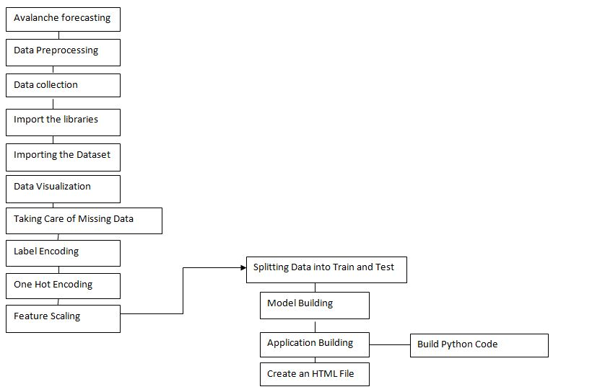

**3.2 Hardware / Software designing**

Python, Python Web Frame Works, Python for Data Analysis, Python For Data Visualization, Data Pre-processing Techniques, Machine Learning, Regression Algorithms

**4.Experimental Investigation**

The compressive strength data for the present work was obtained from the experiments. For generating a reliable data we use the snow deapth , humidity, temperature , wind speed and avalanche occurance in the experimental program.

The casting and testing of avalanche for generating the data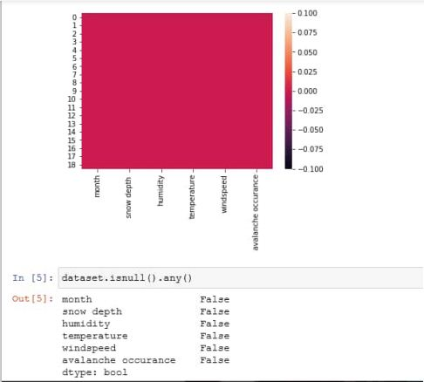 were performed in controlled laboratory conditions.

**5.Flowchart**

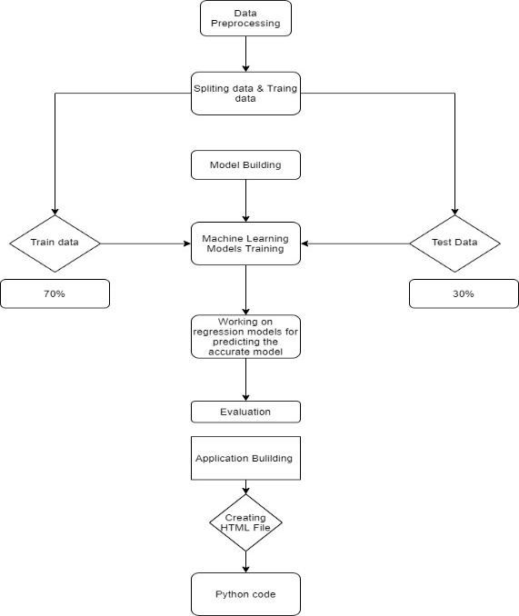

**6.Result:**

We have analysed the Avalanche Forecating by using Machine Learning to Predict the snow deapth , humidity, temperature , wind speed and avalanche occurance . We have used Linear Regression and its variations, to calculate the monthly progress to make predictions and compared their performance. Humidity has highest accuracy and is a good choice for this problem. Humidity trains randomly initialized air with random subsets of data sampled from the training data, this will make our model more robust

**7. Advantages and Disadvantages :**

**Advantages:**

Using Machine learning to predict the avalanche occurance of the time and more accuracy in predicting the approximately close value can be done easily. Its more trust worthy and cost effective .It also reduces the placing the large hardware components for doing the experiments to find the avalanche occurance in different unknown situations.

**Disadvantages :**

There is a 3 % chances that the outcome will not predict the approximate value in that situation it can be troublesome.

**8.Applications:**

* Can predict the Avalanche occurance using the inputs provided.
* Implementable on the website

**9.Conclusion:**

The results are very encouraging. Initially, the modest amount of avalanche occurrence data and its subjectivity seemed to perhaps thwart efforts to apply machine learning to avalanche forecasting in the area. For example, the current data only includes avalanche occurrences near I-90 over approximately twenty predefined avalanche paths that threaten I- 60% , humidity is recorded in the month of march, April, may , June additional avalanche data can be found for the area or maybe avalanche sensors could be installed that give more reliable and safe accounts of avalanche activity. Despite the modest amount of data, the models perform very well.

**10.Future Scope:**

If you open any book on avalanches, you will find a detailed list of features that spell certain doom on the snowy slopes. It is therefore somewhat surprising that the feature list can be improved. To pick the set of features to use, we select an initial set of features commonly known to be good indicators of avalanche activity. These features include: day of season, new snow (0,-1,-2), snowpack height, rain water (0, -1, - 2), wind direction (0, -1, -2), wind speed (0, -1, -2), sky conditions, ram drop (0, -1, -2), high temperature (0, -1, -2), and avalanche activity (-1, -2). Note that 0, -1, and -2 represent the current day, yesterday, and two days previous respectively. If no number is included then it means only the current day is used. Next, a backward feature search algorithm eliminates unnecessary features followed by a forward feature search algorithm to add unenclosed features to the list. Note that during the search, the same folds must be used throughout in order to have stable statistics to compare. Otherwise instead of comparing features, the search algorithm may end up comparing the quality of partitions. During feature selection, 100 or more fields are used in order to have reliable measures of the quality. Furthermore, since missing values still persist in the data, only the training examples without missing values for the tested feature set are used and since the same set must be used throughout for a stable comparsion then only the intersection of the training examples that corresponds to each subset of the possible feature selections is used during the search.

**11.Bibliography :**

**Books:**

[Bra97] A. P. Bradley. The use of the area under the roc curve in the evaluation of machine learning algorithms. *Pattern Recognition*, 30:1145–1159, 1997.

[Bus83] O. Baser. Avalanche forecast with the method of nearest neighbors: an interactive approach. *Cold Regions Science and Technology*, 8:155–163, 1983.

[Cen10] Colorado Avalanche Information Center. Avalanche accident statistics. http://avalanche.state.co.us/acc/ accidents_stats.php, December 2010

.

[CL01] Chi-Chung Chang and Chi-Jen Lin. *LIBSVM: a library for support vector machines*, 2001. Software available at <http://www.csie.ntu.edu.tw/~cjlin/libsvm>.

[FCH+08] Rung-En Fan, Kai-Wei Chang, Cho-Judi Hsieh, Xiang-Rue Wang, and Chin-Jen Lin. LIBLINEAR: A library for large linear *Research*, 9:1871–1874, 2008.

[HM82] J. A. Hanley and B. J. McNeil. The meaning and use of the area under a receiver operating characteristic (roc) curve. *Radiology*, 143:29–36, 1982.

[MBAC03] C. Mc. Cloister, K. W. Baekeland, R. Aspin all, and R. Comedy. Exploring multi-scale spatial patterns in historical avalanche data. *Cold Regions Science and Technology*, 37:299–313, 2003.

[MS06] D. McClung and P. Shearer. *The Avalanche Handbook*. The Mountaineers Books, third edition, 2006.

[Pla99] J. C. Platt. Probabilistic outputs for support vector machines and comparisons to regularized likelihood methods. pages 61–74. MIT Press, 1999.

[PPK08] A. Pozdnoukhov, R. Purvis, and M. Kane ski. Applying machine learning methods to avalanche forecasting. *Annals of Glaciology*, 49:107–113, 2008.

**Data repositories:**

Kaggle.com

**Algorithms:**

The smartbridge teachable.com

**12.Appendix**

